Classe |  | Istituto Tecnico Industriale  GALILEO FERRARIS  SCUOLA PARITARIA D.D.G. 17/06/2002  Via Crescini, 4 – 35126 PADOVA - Tel: 049751977  : www.gferraris.it - : segreteria@gferraris.it |  |  | Anno scolastico
5ª |  |  |  |  | 2024/2025
Verifica Lab Sistemi e reti
Nome |  |  | Cognome
- Scrivi il codice che consente la connessione al database Studente ( in figura ).

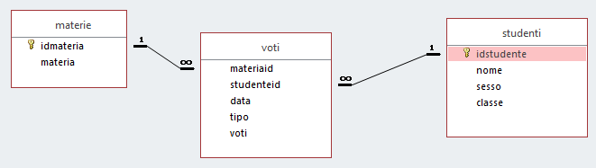
___________________________________________________________________________________________________________________________________________________________________________________________________________________________________________________________________________________________________________________________________________________________________

- Creare una pagina in grado di visualizzare idstudente, classe e voto medio di ogni studente di nome “Mario” presente nel Database precedente (organizzare in modo CRESCENTE per idstudente).
___________________________________________________________________________________________________________________________________________________________________________________________________________________________________________________________________________________________________________________________________________________________________
___________________________________________________________________________________________________________________________________________________________________________________________________________________________________________________________________________________________________________________________________________________________________
___________________________________________________________________________________________________________________________________________________________________________________________________________________________________________________________________________________________________________________________________________________________________
___________________________________________________________________________________________________________________________________________________________________________________________________________________________________________________________________________________________

- Dato il seguente schema di rete identificare i dispositivi e dare dei cenni ai mezzi trasmissivi che permettono il traffico dati nella stessa.








